Handout 1: A Busy Street Scene

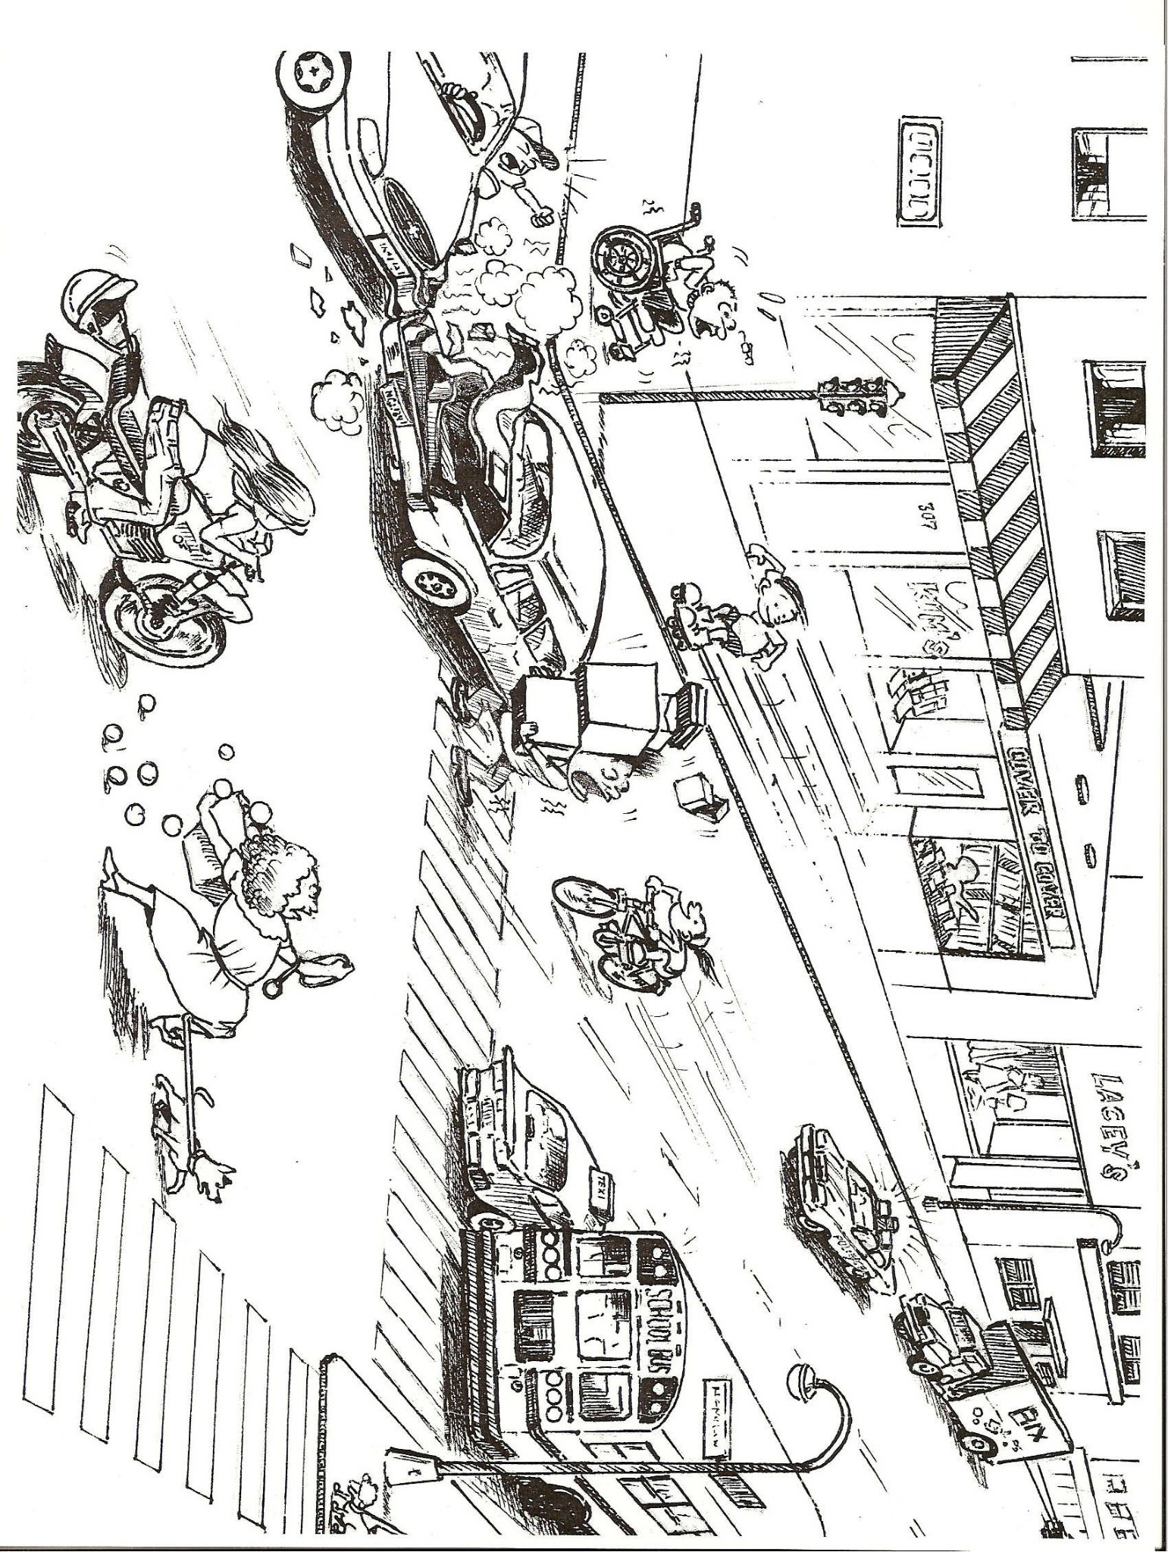

Handout 2A: Is This a Good Paragraph?

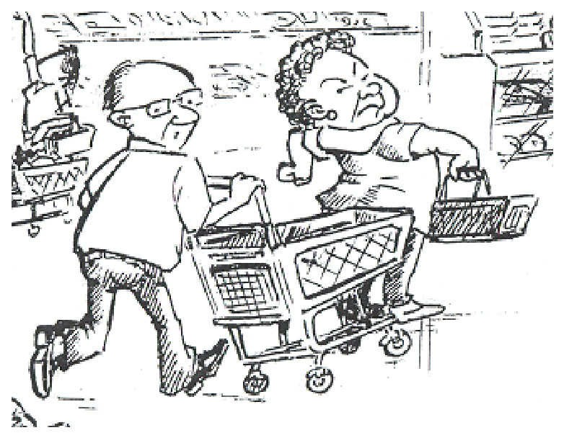

He has glasses. I see a basket and a shopping

cart. The store opens at 9:30 every morning. The

food is fresh. My friend wants to work at a store.

I’m hungry. I usually eat chicken and rice for lunch.

Handout 2B: Is This Paragraph Better?

He just hit a lady with his shopping cart. I think she

is going to yell at him. She’s very angry. He should

apologize to her. This man is not paying attention.

Handout 2C: A Much Clearer Paragraph

Handout 3A: What is the Main Idea?

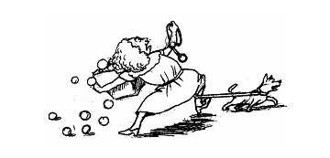

Which of the sentences below best describes this drawing?

A. This woman is walking her dog.

B. This woman has curly hair.

C. This woman is in the street.

D. This woman is not safe.

E. This woman is holding a bag of groceries.

Handout 3B: Adding Detail Sentences

Let’s write a short paragraph about this drawing. The topic sentence from Handout 3A is already written down. Now we need to write three to four more detail sentences. These sentences should give more information about the main idea in the topic sentence. Detail sentences will answer these questions: How do we know this woman is not safe? What is happening in the drawing that shows she is unsafe? What might happen next? What do you think the lady should do?

This woman is not safe.
Handout 4A: What is the Main Idea?

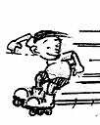

Which of the sentences below best describes this drawing?

A. This is a boy.

B. He is about eight years old.

C. This boy is not being careful.

D. The boy in this drawing is downtown.

E. I think this boy likes sports.

Handout 4B: Adding Detail Sentences

Let’s write a short paragraph about this drawing. The topic sentence from Handout 4A is already written down. Now we need to write three to four more detail sentences. These sentences should give more information about the main idea in the topic sentence. Detail sentences will answer these questions: How do we know the boy isn’t being careful? What is he doing? What is he not doing?
What problem might occur? What should the boy do?

This boy is not being careful.

Handout 5A: Matching Exercise

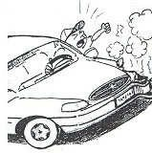

This man is very angry because he just had a
car accident downtown. His sees that his car is
damaged, so he is very mad. He doesn’t want to
spend a lot of money to repair his car. This driver
thinks the man with the boxes caused the accident,
so he is shouting out his window at him. He called
9-1-1, and the police are going to help him soon.

Handout 5B: Matching Exercise

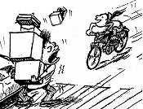

This man is frightened. A short time ago, he picked
up some boxes at a store, and then he went back to
his car. He used the crosswalk, but he parked his car
in the middle of the street. Now he is very worried
because he thinks the girl on her bicycle is going
to hit him. She doesn’t see the man, and he can’t
get out of the way because he is holding the boxes.
Handout 6: Describing a Busy Street Scene
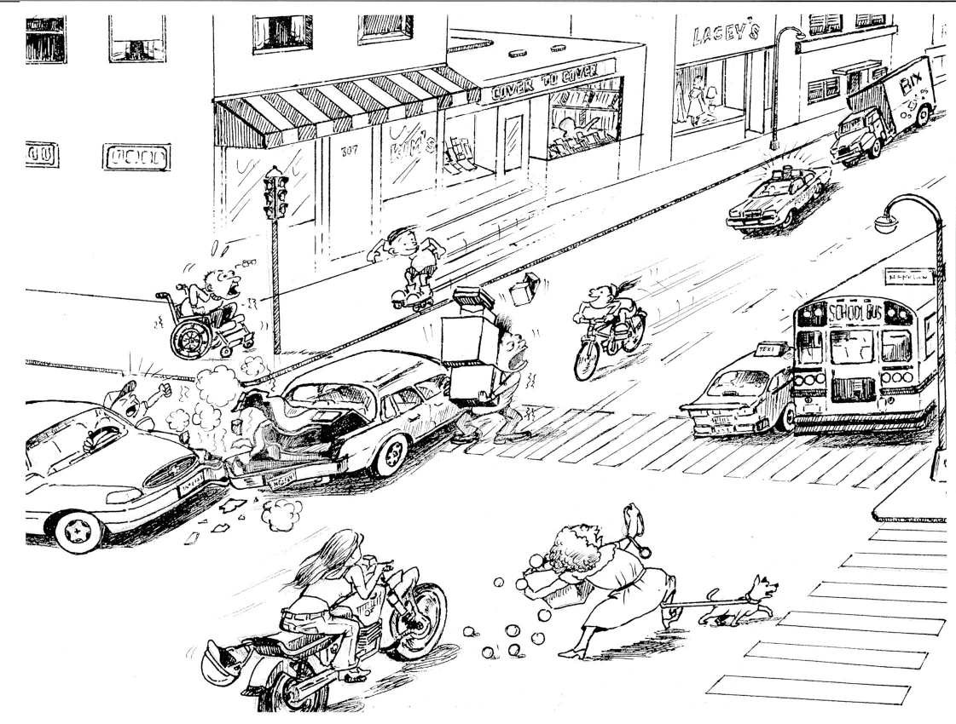

Art by Khun Lwin

